

Box 585, Center Road

Spanish Lookout, Cayo

Belize

Tel: 501-823-0254

Fax: 501-823-0311

[www.universalhardware.bz](http://www.universalhardware.bz)

May 15, 2015

**Company Profile**

Universal Hardware Co. Ltd became authorize exclusive dealer of Foton Pickup Trucks (Tunland) and Vans (View CS2) by Beiqi Foton Motor Co., Ltd of Beijing, China in 2013. Foton is ranked No.4 in auto industry and No.43 in the top 500 China's Most Valuable Brands. Foton is changing the perception of what China can produce and Universal Hardware is so far happy and confident to partner with Foton in Belize. In a general way of comparison, Foton Tunland Pickup Trucks and View CS2 Passenger Vans are very similar to the Toyota Hilux and Hiace Van, respectively, with the biggest difference being a 20% lower price tag and superior after sales service.

Since August 2013, Universal Hardware has sold 12 Tunland pickup trucks and 20 View CS2 Vans in Belize, both being powered by a 2.8 liter Cummins engine. We also have a Customs Bonded Warehouse where we can operate up to 12 Tunland Pickup trucks and 6 Vans until Import Taxes have been arranged. (Note picture below of Customers Bonded Warehouse) We already have an inventory stock of 215 different spare parts in stock, a total value of BZD $82.000.00. (Note picture of our Parts Warehouse below). Our Service Technician, Mr. Ronald Braun, has already received training from China on how to service all our Foton vehicles. Our Service Center is equipped with servicing area, ramp, and Computer to diagnose any problem that may occur. (Note picture of our Service Center below)

Universal Hardware is confident in the quality of our Foton brand of vehicles and we are poised to become a formidable outstanding option for Pickup Trucks and Passenger Vans in the Belize Market.

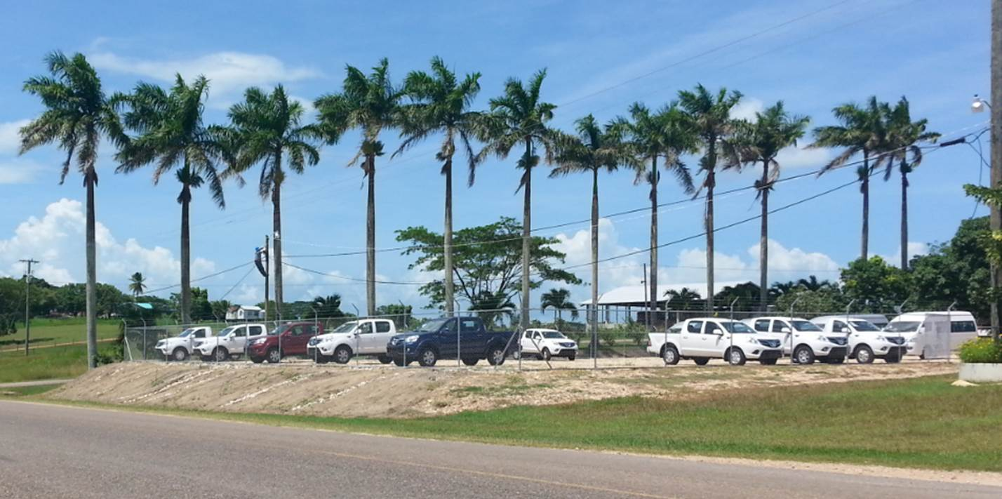

**Customs Bonded Warehouse in Spanish Lookout**

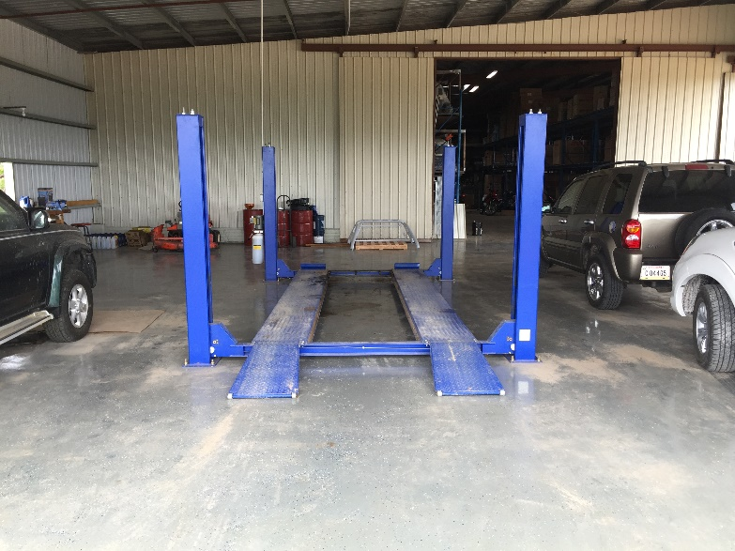

**Service Center in Spanish Lookout**

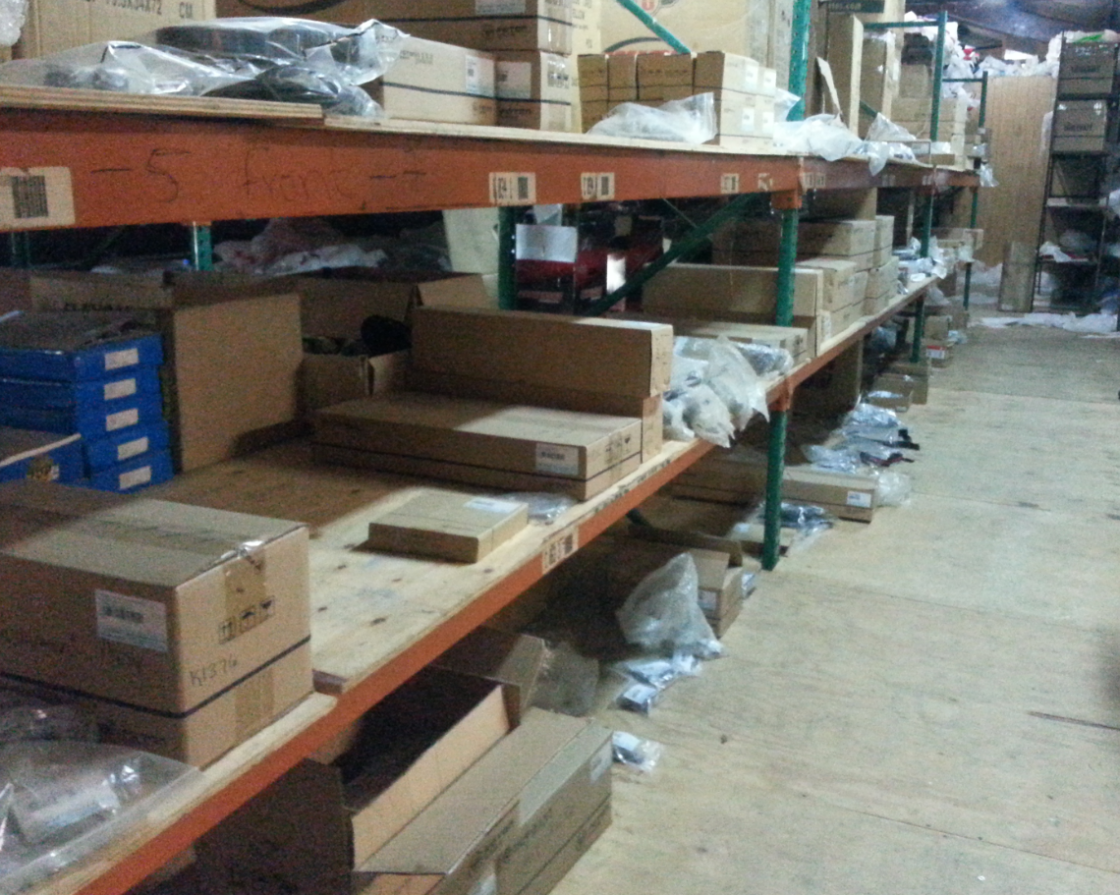

**Spare Parts in Stock at Spanish Lookout Warehouse**